Step1: Click on Change button

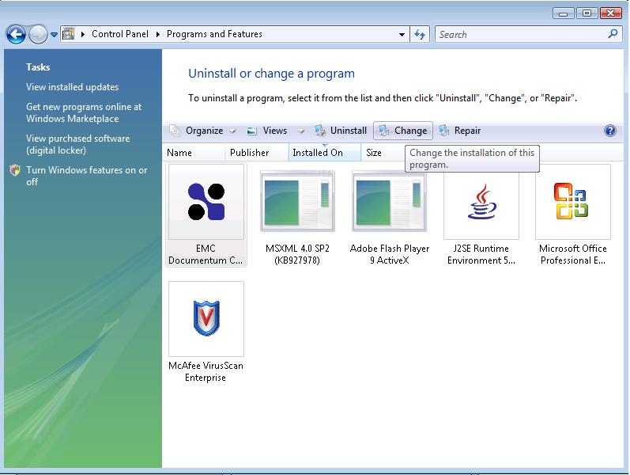

Step2: Welcome screen of Install Shield Wizard for EMC DCO

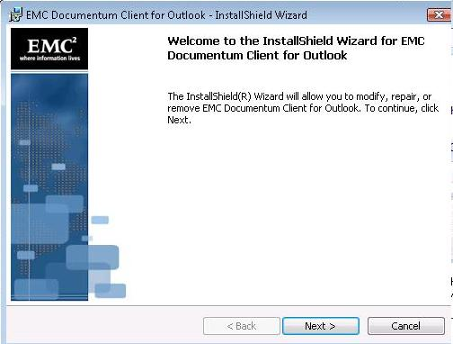

Step3: Select the radio button before “REMOVE” option

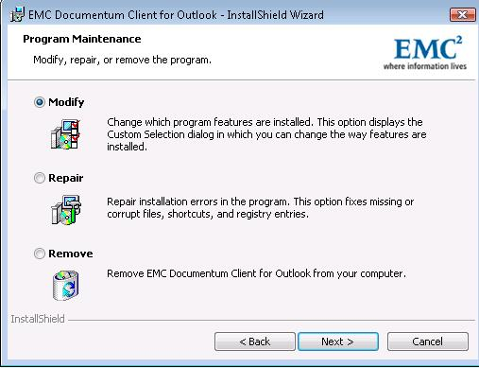

Step4: Click on the “REMOVE” button on the “Remove the Program” screen

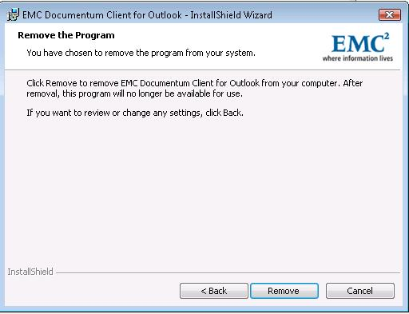

Step 4: Finish to exit the “Install shield wizard”

